Statistics Lecture 7.2: Finding Confidence Intervals for the Population Proportion

Estimating population proportion from sample proportions:

What we need:
- Random sample
- Conditions for binomial
  - Fixed number of trials
  - Trials are independent.
  - Two outcomes (success/failure)

  - 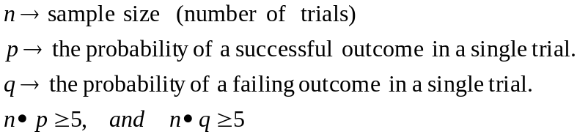

Point estimate:
A single value used to approximate a population.

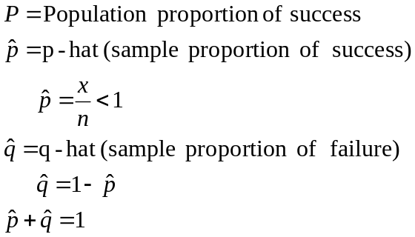

is a point estimate for P

Example
Touch therapist 280 trials therapist chose correct hand 123 times.
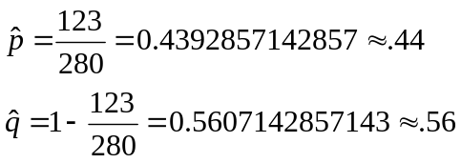

No idea how accurate the point estimate above really is?

Confidence interval
Range of numbers used to estimate a population parameter.
They have:
- Confidence level
The confidence level gives us the success rate of the procedure used to construct the confidence interval.

How confident you are that the actual value of the population parameter will be inside the interval.

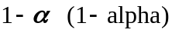 is the complement of a confidence level.

Most common confidence level.
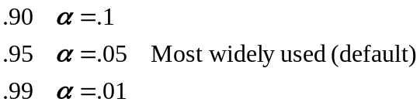

Larger the confidence level the wider the range of numbers

Example
The 95% confidence interval for P is 
I don’t know what P actually is? But I am 95% sure it falls in this range.

Critical Value: A z-score that separate the likely region from the unlikely region.



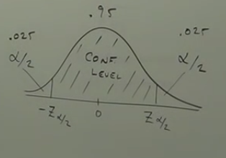

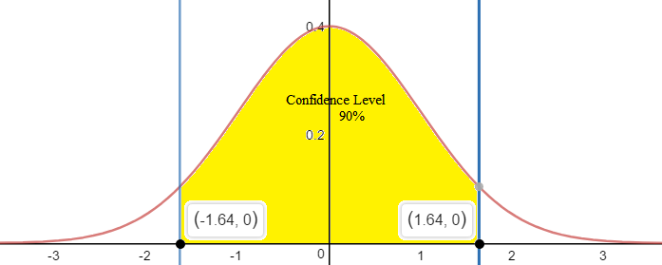

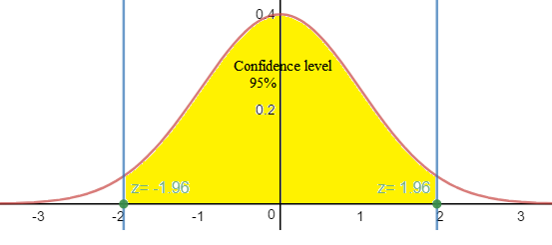
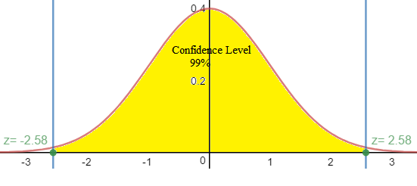

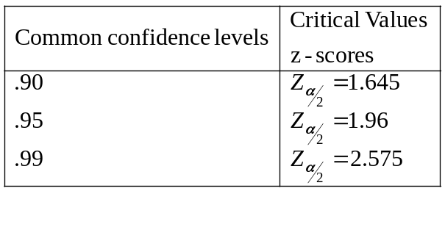
Margin of Error: E
The maximum difference between and .


Steps:
- Find 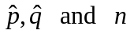
- Use the confidence level to find critical values 
- Find E (margin of Error)
- Confidence Interval
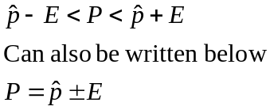

Example
Touch therapist 280 trials therapist chose correct hand 123 times.

Construct a 95% confidence interval for P.

2) Critical values
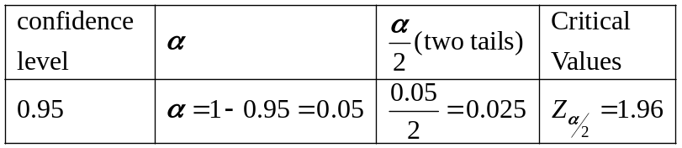
- Margin of error

4) Confidence Interval
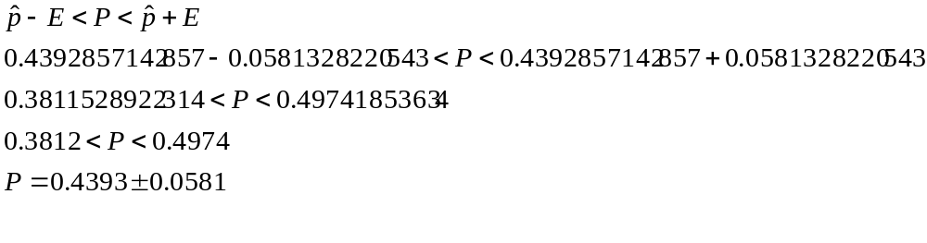
NOTE:
As sample sizes increases n then the margin of error decreases
Finding the required sample size:
Given a Margin of Error: ; you can find the sample size needed to get that E:
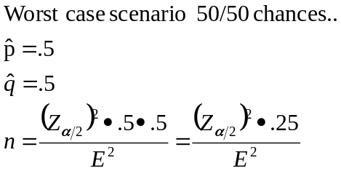

Finding the required sample size:

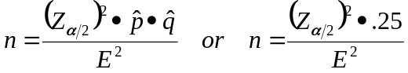
Example
We want to determine the percentage of U.S. people who use @ 95% Confidence interval
What does the sample size need to be to ensure a margin of error of 4%

Case 1
16.9% of people used email in 1997.
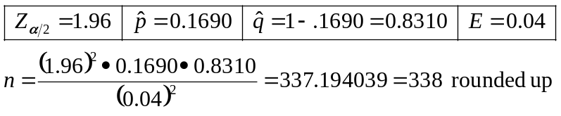

Case 2
Assume we nothing about previous email usage,


Given a Confidence interval,
Find 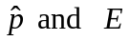

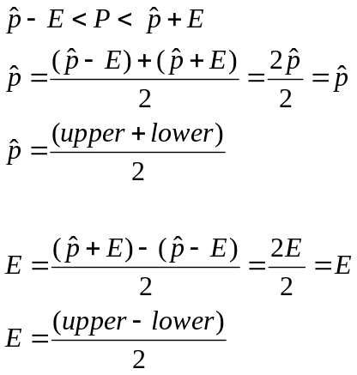

Example
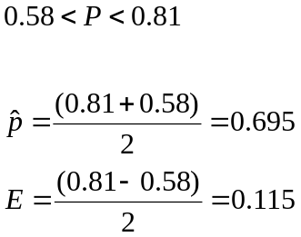

Example
In a study 1300 randomly selected medical Law Suites, 900 of them were dropped.
A dropped case is considered successful.

- Find the best point estimate for a population proportion.
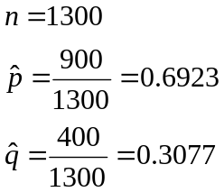

- Construct a 99% Confidence Interval.
          - Critical values
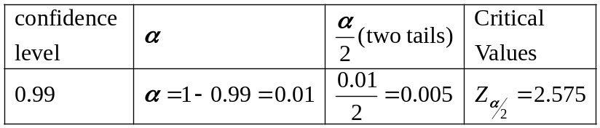
          - Margin of error
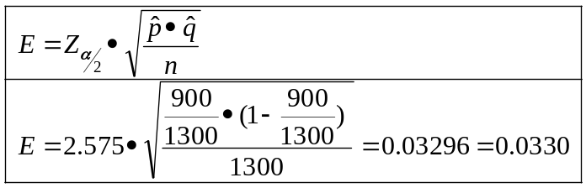
          - Confidence Interval
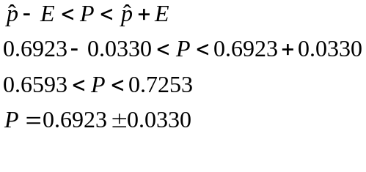
- Are Most cases dropped?
Yes, because with 99% sure that 66 thru 73% of cases are dropped with a 3% margin of error.

